Оглавление

1. Сравнение flash-расчета для смесей чистых компонент 2

1.1. C1 – C3 0.5 : 0.5 2

1.2. C1 – C2 – C3 0.6 : 0.3 : 0.1 2

2. Сравнение flash-расчета с С6+ компонентами 3

## Сравнение flash-расчета для смесей чистых компонент

## C1 – C3 0.5 : 0.5

Таблица 1.1. – исходные данные

|  |  |  |  |  |  |  |  |  |  |
| --- | --- | --- | --- | --- | --- | --- | --- | --- | --- |
| Софт | Молекулярная масса | | Рcrit | | Tcrit | | Ацентрический фактор | | BIP |
| C1 | C3 | C1 | C3 | C1 | C3 | C1 | C3 |  |
| PVTsim | + | + | 46 | 42,46 | 190,59 | 369,79 | 0,08 | 0,152 |  |
| **Python** | **16.043** | **44.097** | **46.04** | **42.46** | **190.6** | **369.79** | **0.013** | **0.152** |  |

Таблица 1.2. Результаты flash-расчетов

|  |  |  |  |  |  |  |  |  |  |  |
| --- | --- | --- | --- | --- | --- | --- | --- | --- | --- | --- |
|  | **P = 30 бар, Т = 10 С** | | **P = 50 бар, Т = -30 С** | | **P = 60 бар, Т = 30 С** | | **P = 80 бар, Т = 40 С** | | **P = 60 бар, Т = 50 С** | |
| PVTsim | Python | PVTsim | Python | PVTsim | Python | PVTsim | Python | PVTsim | Python |
| Fv (доля пара) | 0.6042 | 0.6078 | 0.1114 | 0.1230 | 0.5063 | 0.5136 | 0.3841 | 0.3921 | 0.8589 | 0.8720 |
| Z газа | 0.8249 | 0.8184 | 0.7389 | 0.7272 | 0.6937 | 0.6822 | 0.5772 | 0.5634 | 0.6349 | 0.6212 |
| Z жидкости | 0.1089 | 0.1010 | 0.1756 | 0.1613 | 0.2256 | 0.2111 | 0.3359 | 0.3185 | 0.2443 | 0.2303 |
| Состав газовой фазы | | | | | | | | | | |
| C1 | 0.71956 | 0.7183 | 0.931 | 0.9307 | 0.68615 | 0.6851 | 0.62126 | 0.6207 | 0.53903 | 0.5355 |
| C3 | 0.28044 | 0.2817 | 0.069 | 0.0693 | 0.31385 | 0.3149 | 0.37874 | 0.3793 | 0.4697 | 0.4645 |
| Состав жидкой фазы | | | | | | | | | | |
| C1 | 0.16482 | 0.1617 | 0.44595 | 0.4396 | 0.30906 | 0.3045 | 0.42439 | 0.4221 | 0.26248 | 0.2581 |
| C3 | 0.83518 | 0.8383 | 0.55405 | 0.5604 | 0.69094 | 0.6955 | 0.57561 | 0.5779 | 0.73752 | 0.7419 |
| Ki | | | | | | | | | | |
| C1 | 4.366 | 4.4414 | 2.088 | 2.1171 | 2.22 | 2.2495 | 1.464 | 1.4704 | 2.054 | 2.0751 |
| C3 | 0.336 | 0.3360 | 0.125 | 0.1237 | 0.454 | 0.4528 | 0.658 | 0.6563 | 0.625 | 0.626 |

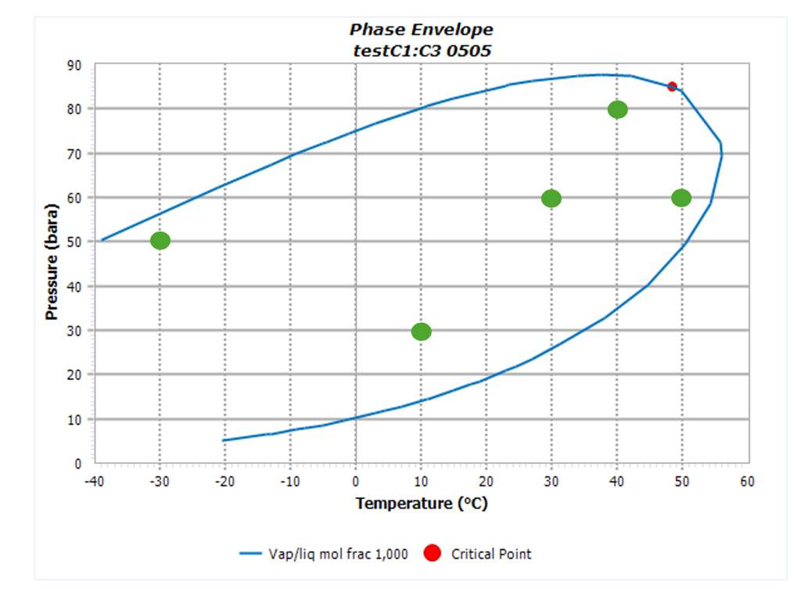

Фазовая диаграмма с точками расчета

## C1 – C2 – C3 0.6 : 0.3 : 0.1

## 2. Сравнение flash-расчета с С6+ компонентами

### 2.1. Состав пластовой нефти

Таблица 2.1. – исходные данные для состава

|  |  |  |  |  |
| --- | --- | --- | --- | --- |
| Компонент | Мольная доля, % | Р крит, МПа | Т крит, С | Ацентрический фактор |
| CO2 | 0,215 | 73.76 | 31.050 | 0.225 |
| C1 | 28,201 | 46.00 | -82.550 | 0.008 |
| C2 | 14,907 | 48.84 | 32.250 | 0.098 |
| C3 | 11,513 | 42.46 | 96.650 | 0.152 |
| iC4 | 1,429 | 36.48 | 134.950 | 0.176 |
| nC4 | 3,721 | 38.00 | 152.050 | 0.193 |
| iC5 | 1,177 | 33.84 | 187.250 | 0.227 |
| nC5 | 1,130 | 33.74 | 196.450 | 0.251 |
| C6 | 1,901 | 29.69 | 234.250 | 0.296 |
| C7 | 3,082 | 29.45 | 263.338 | 0.337 |
| C8 | 4,151 | 27.42 | 284.893 | 0.374 |
| C9 | 3,400 | 25.06 | 308.928 | 0.420 |
| C10 | 3,087 | 23.29 | 329.365 | 0.463 |
| C11 | 2,526 | 21.77 | 348.076 | 0.501 |
| C12 | 2,141 | 20.57 | 367.841 | 0.543 |
| C13 | 2,062 | 19.61 | 386.745 | 0.584 |
| C14 | 1,813 | 18.71 | 405.769 | 0.626 |
| C15 | 1,339 | 17.86 | 424.823 | 0.670 |
| C16 | 1,134 | 17.16 | 443.239 | 0.712 |
| C17 | 0,953 | 16.50 | 459.179 | 0.750 |
| C18 | 0,949 | 16.03 | 474.134 | 0.785 |
| C19 | 0,999 | 15.75 | 487.214 | 0.813 |
| C20 | 0,667 | 15.45 | 499.692 | 0.841 |
| C21 | 0,623 | 15.08 | 515.876 | 0.875 |
| C22 | 0,585 | 14.81 | 529.805 | 0.905 |
| C23 | 0,495 | 14.57 | 542.482 | 0.930 |
| C24 | 0,469 | 14.36 | 554.974 | 0.955 |
| C25 | 0,408 | 14.15 | 568.216 | 0.980 |
| C26 | 0,361 | 13.96 | 581.277 | 1.003 |
| C27 | 0,342 | 13.77 | 595.067 | 1.027 |
| C28 | 0,300 | 13.61 | 607.800 | 1.047 |
| C29 | 0,278 | 13.46 | 620.318 | 1.066 |
| C30 | 0,240 | 13.33 | 632.706 | 1.083 |
| C31 | 0,234 | 13.21 | 645.046 | 1.099 |
| C32 | 0,212 | 13.09 | 657.198 | 1.113 |
| C33 | 0,195 | 12.98 | 669.245 | 1.125 |
| C34 | 0,180 | 12.88 | 681.193 | 1.136 |
| C35 | 0,170 | 12.79 | 693.047 | 1.145 |
| C36+ | 2,407 | 12.70 | 704.813 | 1.153 |
| Сумма | 100 |  |  |  |